**3: Kubernetes Fundamentals – Introduction**

--- **note** – we are going to understand about fundamental core concepts of pod, Replicaset, Deployment & service.

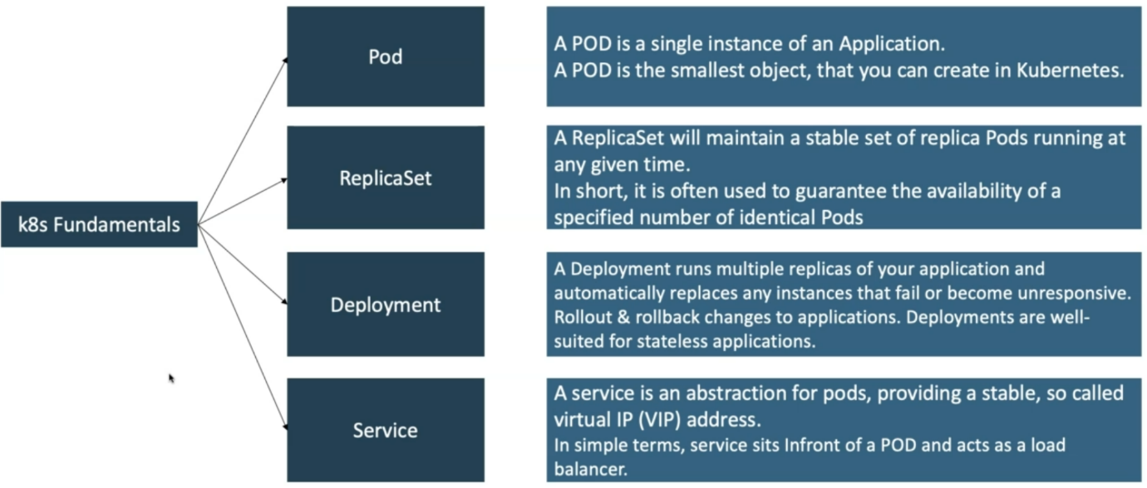

--- **note** – we are going to discuss about what our approach is for implementing these fundamentals. We will use imperative and declarative concepts to implement the kubernetes core concepts.

**Kubernetes – imperative & declarative**

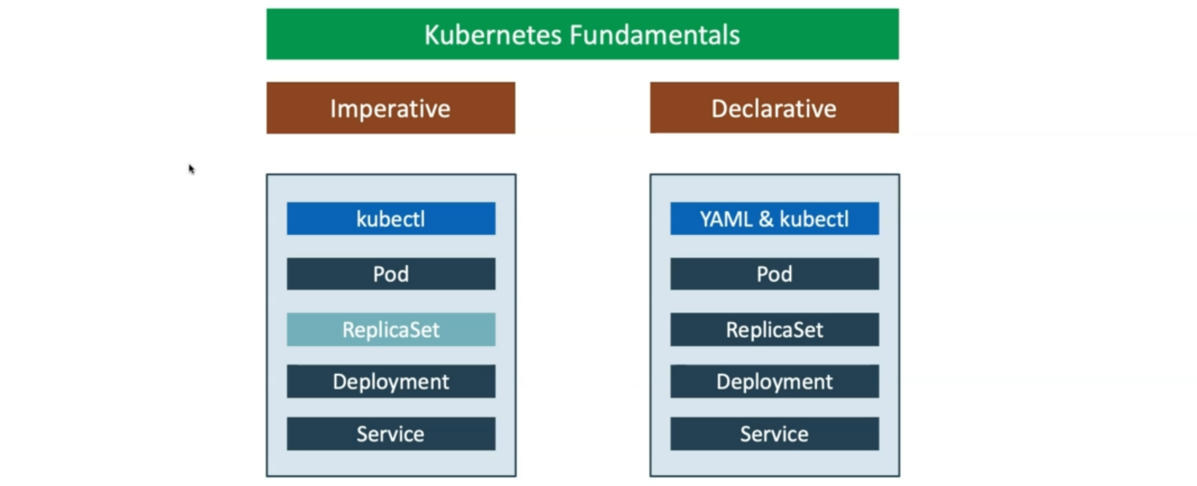

**Imperative**

--- **kubectl** – using kubectl command to create pods, deployments and service imperatively. For Replicaset we really don’t have a kubectl command directly do it. We are going to use yml file to create them.

**Declarative**

--- in declarative approach, we are going to use yml language to create kubernetes manifests and then we will use **kubectl** to create pods, Replicaset, Deployment, Service.

--- **note** – we are going to create the kubernetes fundamentals in 2 ways. 1st one is imperative way, 2nd is declarative way.